How to play

Dungeons - The Roguelike

Dungeons is a game where there is no ending , only levels that continuously get harder. Upon starting the game you’ll be greeted by a cold stone dungeon with enemies everywhere (You’re the @ sign).

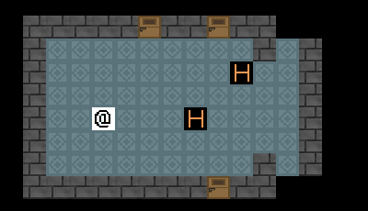

You’ll notice that nothing is happening yet. You need to use a “turn”. If you move using the arrow keys, wait using “.”, or use an attack, then your “turn” will be up. Once you use your “turn”, everything else takes a “turn” too. Enemies move, things bleed, and most everything else.

In the top left corner you’ll see your hud. This shows your inventory, your equipped items, and your skill levels.

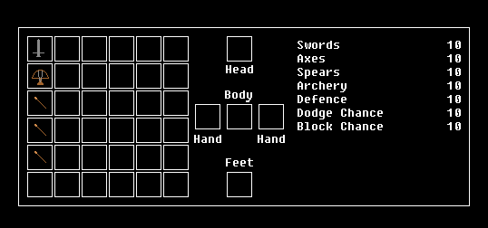

And in the top right corner is your status.

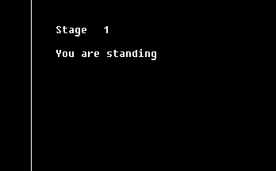

To move around use the arrow keys. Try avoiding enemies! If they are in the tile that is right next to you, then they can attack you (or you can melee attack them).

If you want to “wait a turn” then press the period ( “.” ) . This is good for getting enemies closer to you to get the first attack on them.

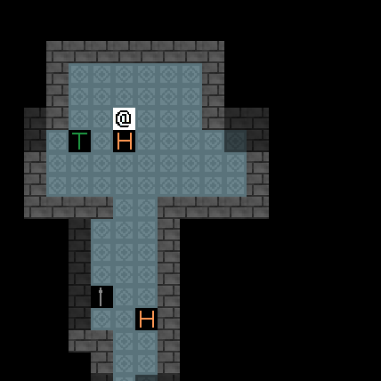

If you mouse over the enemy then you can see their status pop up.

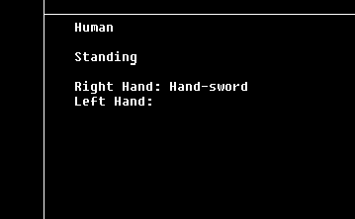

As you can see, this “Human” enemy is holding a sword in its right hand. We should probably equip a weapon before attacking too. Just click your sword item, and drop it into one of your hand slots.

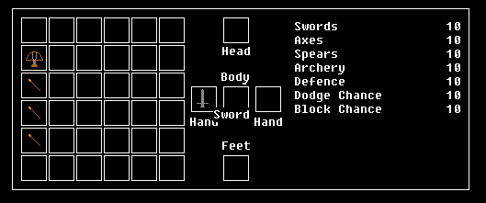

To attack, simply left click the enemy while standing next to them. This menu below will appear asking us what body part we would like to attack. After we select a part by clicking the appropriate number key we will be asked what to attack with. Either our left hand, our right hand, or our feet. Since we placed a sword into one of our hands we can attack using the sword.

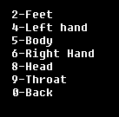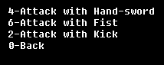

When attacked you have a change to dodge or block the enemy’s attack, and so does your enemy. After a few hits to the neck of the “Human” enemy’s we managed to kill him. We also decapitated him.

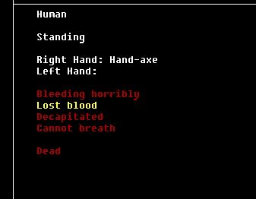

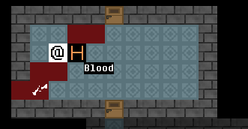

When you severe a body part it will fly off leaving a trail of blood in the way. If it hits a wall before it lands, it will bounce off and back onto the ground, leaving a stain on the wall. You can go onto pick up the blood and severed head (not that it does anything other than clear up any messy areas or give you a little victory “trophy”. All of the same type of damage that can happen to enemies can also happen to you.

But it also seems that we got hurt a lot in the process. Be careful that your bleeding isn’t too high or else you’ll bleed out over time. “Bleeding” slowly goes down and “blood lost” goes down even slower. When you are bleeding you will leave a trail of blood wherever you go. Enemies will do the same.

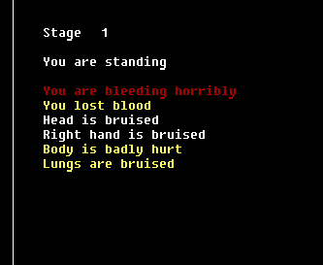

Successful hits on enemies can level up the skill of whatever weapon you are using making your attacks stronger. Dodging, blocking, and getting hit while wearing armor will all also increase certain skills. When your skills are higher, the chance of missing your attack using its appropriate weapon will decrease also. Continually attacking dead enemies will also slowly increase your skills but with the drawback that it could break your weapon.

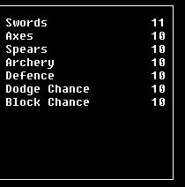

If you aren’t careful then you could break a body part. If you break a leg then you can’t walk and your shoes get dropped. If you break an arm, the item you were holding gets dropped on the ground and you can no longer equip anything into that slot. If a body part gets severed then it will never come back, even if you go down to the next level.

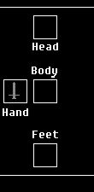

Now, to continue exploring the dungeon… Areas of the dungeon that you have already seen will appear visible as shaded areas. Areas that you can currently see in your field of vision will appear brighter, and allow you to see the items and enemies in these areas. Doors allow you to enter different rooms of the dungeon. When a door is used, it will stay open for a couple of “turns”, allowing you to see through them, and for other enemies to pass. Enemies cannot pass other enemies, or through closed doors, allowing for certain strategies to take place.

Random items will be littered throughout the dungeon floors. You can get near them and pick them up. To quickly add them to your inventory, just drop the items onto yourself and they will be placed into an empty spot in your inventory.

It seems that we have found an axe. Axes do slightly more damage than swords. There are also spears to be found, which aren’t very good for severing body parts, but are ideal for bleeding and lung damage!

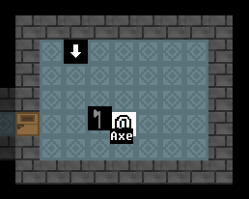

We have also found an arrow that points down. This tile, once walked upon, will take you to the next dungeon level. Beware though! The levels get increasingly harder and going into lower levels without gaining a few levels and some items is suicide! Try to avoid going down until you get stronger. However, going down a level will heal all of your status alignments except for severed body parts and lung damage.

Another enemy? Since it’s a human the enemy will be holding a weapon. As you can see, this human is holding a sword. We want that sword! Try attacking it but this time attacking the “right hand”. Hands and feet are far easier to break or severe than throats or heads. Watch out, because the same thing can happen to you!

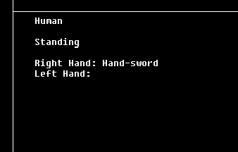

After severing the hand, the enemy will drop its sword (along with a severed arm). After we finish off this enemy we can go and pick up the sword. The human is much weaker now without its weapon, but it will still try attacking you with punches and kicks until killed. You’ll want to pick up all the weapons you can find, because with every hit you land, you have a chance of breaking your weapon. If you don’t have a weapon you’ll have to resort to your bare fists and feet, or run until you find a weapon on the ground.

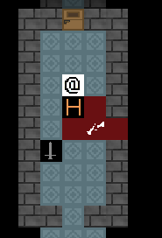

To attack with your crossbow you must place the crossbow into one of your hands and a bolt into the other.

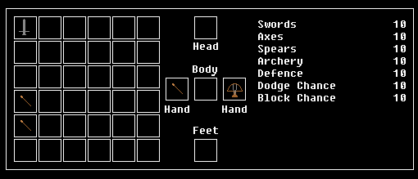

To shoot an enemy you must now “Click the scroll wheel” while moused over an enemy. This will consume a bolt. Luckily, bolts can be held by supplier enemies who will drop them if you break their hand. They can also just be found laying on the ground.

Armor can be found on the ground. There are helms, chestplates, and shoes. They can all be equipped into the appropriate slots to decrease damage when hit in those places. Steel armor (Silver) has a better defense than Copper Armor (Brown).

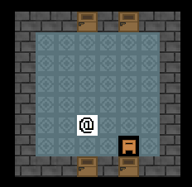

When an enemy’s legs are broken they will lose their ability to stand. This means that they can no longer move around, but can still attack.

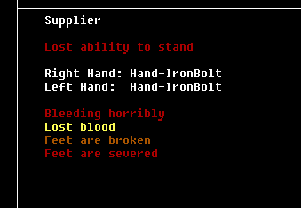

Also, when the feet are severed, the two feet will fly off just like any other body part will.

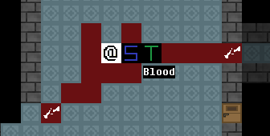

When you attack an enemy to the chest, and if the attack is strong enough, then the enemy will take “lung damage”.

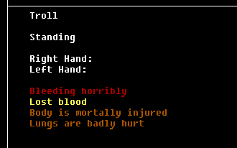

If the lung damage is high enough then the enemy will lose the ability to breath. If this happens then in a dozen or so turns later the enemy will die of suffocation. Spears are ideal for destroying an enemy’s lungs. Spears always do high lung damage on a body hit. One good strategy would be to break an enemy’s legs so that they cannot move and then destroy their lungs. After a few turns they will die on their own.

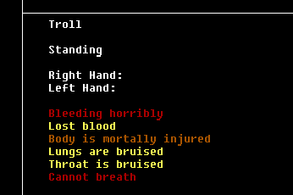

Sometimes you will be faced with a hoard of enemies at once. One good way to avoid the entire battle, would be to dodge around the enemies, and once you have them in a straight path or corridor to break the legs or kill the enemy in front. Enemies cannot pass other enemies (along with closed doors) so it should trap all of the other enemies behind.

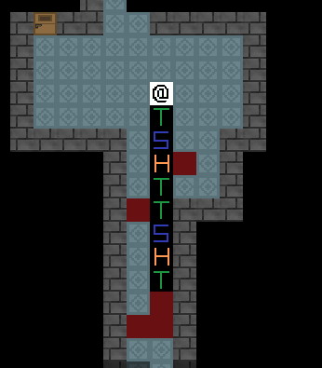

Right clicking a dead enemy while standing next to them will cause you to start dragging them. The will leave a trail of blood if they are bleeding. This can be used to block other enemies. Right clicking them again will cause you to stop dragging them.

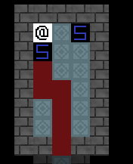

On some computers this game may lag. To get rid of a lot of lag you can press “+” or “-“ to lower how much of the map around you can see. You can also edit the tileset.bmp image to make tiles look different. Pressing “s” will make you crouch slowing your movement by half and giving all enemies 2 turns for every 1 turn you make. If your feet get broken or severed then you are still able to move (unlike enemies), but the affect is the same as crouching and you cannot get up.



ENEMIES

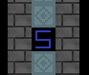 - Suppliers are the weakest enemies in the entire game. However their dodging chance is very high. They carry ammo for your crossbow.

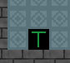 - Trolls do not carry any items, but their punches and kicks do much more damage than any other enemies. They have the highest block chance.

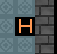 - Humans are the strongest enemies in the entire game, but only when they continue to hold their weapons. They have a low dodge and block chance.

Suicide

If you ever feel like it’s hopeless to continue and that you’re going to die soon, you can also commit suicide. Press “shift+s” to target a body part and then attack it with whatever hand you want. This can be used to test out the affects of what happens when you attack a certain body part.

This game is hard!

If you’ve already played it then you’d understand. This game is rather hard! Getting to level 2 is already a hard thing to do. Enemies can be right in front of you as soon as you enter a door, or appear all around you as soon as you start the game or go down a level. Weapons can break at any instant whenever you attack, sometimes on the first enemy. With a combination of luck and thinking about your moves before you take them, you could go far!